**CS 207: Applied Database Practicum**

**In-Class Activity 5: Introduction to Joins and Stored Procedures, 10th September, 2018**

In this activity, you will be working in Mysql.

Q1. In this question load the database from the dump file (join.sql) given in moodle

The Database has the following tables:

* Customers: stores customer’s data.
* Products: stores a list of scale model cars.
* Orders: stores sales orders placed by customers.

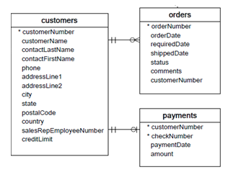

1. Display all customer names (**customers table**) and their orderNumbers (**orders table**).
2. Show the number of orders (**orders table**) placed by each customer (**customers table**).
3. Display all customer names (**customers table**) that have not placed any orders (**orders table**)
4. Display all the customer details (**customers table**) and payment details (**Payments table**) for the **customerNumber 119.** (There should be no redundant columns)
5. Find the total amount (**payments table**) paid by each customer (**customers table**).
6. Display the total amount paid (**payments table**) for each order (**orders table**)

BONUS: ONLY if you have done the above steps, then you can try this bonus for an extra point.

Q2. Load the world.sql dump file uploaded in moodle (No need to load the dump file if it is already uploaded in your mysql server)

1. Create a stored procedure to display the country name, headofstate of the country and continent name for ASIA or EUROPE
2. Create a stored procedure that outputs the highest population (**value**) from the continents **EUROPE** and **AFRICA** and then use the value to find the name of that country.